5. SHEET METAL OPERATION
SHEET: $Thickness≤6mm$ | PLATE: $Thickness>6mm$

SHEET METAL OPERATION
Cutting Sheet Metal Operation |  | Forming Sheet Metal Operation
TYPES OF SHEET METAL OPERATIONS
Major Operations | - Punching or Piercing  - Blanking | Cutting Sheet Metal Operation
 | - Deep Drawing  - Bending | Forming Sheet Metal Operation
Minor Operations | - Perforating  - Nibbling  - Lancing  - Slitting  - Notching  - Trimming | Cutting Sheet Metal Operation
PUNCHING OR PIERCING & BLANKING:
Blanking and piercing are shearing processes in which a punch and die are used to create workpiece by shearing of sheet metal ($τ≥σ_{ut}$). Terminologies are given according to workpiece surface requirement.
Blank/ Slug: Removed part from the sheet. | $$Radial Clearance (c)= Die Size-Punch Size$$
Clearance Angle: For easy removale of blank surface is made inclined. It’s generally taken 3$°$ to 5$°$.
$$Punch Size=Dia. Of Punch \& Die Size=Dia. of blank or Slug produce$$
PUNCHING OR PIERCING | BLANKING
Punch Size = Hole Size  D.S. = P.S. + 2C Hole Size => Punch Size  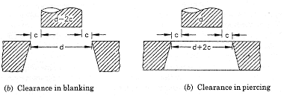 | Blank Size = Hole Size  P.S. = D.S. - 2C Blank Size => Die Size  

MECHANISM OF PUNCHING & BLACKING: Shearing & Tearing.
1) Just before the punch contacts work, 2) Punch begins to push into work, causing plastic deformation, 3) Punch compresses and penetrates into workpiece causing a smooth cut surface, and 4) fracture is initiated at the opposing cutting edges the separate the sheet.
Shearing: Creation of Fracture. | Tearing: Propagation of Cracks/ Fractures in respective direction.
Burnishing Area: Due to tearing, Unfinished surface generated. This unfinished surface area is call Burnishing Area.
Penetration depth ($K_{t}$): It’s Depth of Punch which required to travel only some % of thickness of sheet for completing the operation. Generally, $K_{t}=\left(1/3\right)Sheet Thickness$
% Penetration required for completing shearing operation ($K$): % of thickness of sheet.
$$K_{Brittle}<K_{Ductile}$$ | $$20\%≤K≤60\%$$ | $$K_{t}=Kt$$

Work Done or Energy required for operation:  $$E=F_{max}K_{t}$$ | $K_{t}=Kt$,  $F_{max}=τ_{u}A_{Burnishing}$,

SELECTION OF OPTIMUM CLEARANCE
$$c≫≫c_{optimum}$$ | $$c≪≪c_{optimum}$$ | $$c=c_{optimum}$$ | $$c_{optimum}∝tσ_{ut}$$  $$c_{optimum}∝t$$
Bending/ Plastic Deformation Takes Place | Washer is formed | $$2\% t≤c≤8\% t$$
Shaving: It’s used for removing burnishing area. $c=1\% t$.
CASE-I: c is not given,  $$c=0.0032t\sqrt{σ_{ut}}$$  Where, $σ_{ut}$= MPa | CASE-II: $σ_{ut}$ is not given, |  | CASE-II: c, t &${ σ}_{ut}$ given.
 | $$c=5\% t(For t<2mm)$$ | $$c=10\% t(For t>2mm)$$ | Use Given c.
LOAD OR FORCE & WORK DONE IN PUNCHING & BLANKING:
$$F_{max}=τ_{u}A_{S}$$  $$A_{S}=πdt(For Circular Section)$$  $$A_{S}=Lt(For Strait Cut Section)$$  $$E=F_{max}K_{t},$$  Where, $K_{t}=Kt$ | $A_{S}=A_{Burnishing}$,  L= Length of Cut,  $F_{max}=$ Maximum Punch Force,  $d$ = Dia. of Die,  $t$ = thickness of the plate,  $τ_{u}=$ Ultimate Shear Strength of the workpiece material
COMPRESSIVE STRESS ON PUNCH:
$$σ_{c}={F_{max}}/{A_{punch}}$$  $$σ_{c}={4τ_{u}t}/d\left(For Circular Punch\right)$$  Limiting Condition: $σ_{c}≤σ_{uc}$  Using this condition, we can find $d_{min}$. | $σ_{c}$= Compressive Stress in punch,  $A_{punch}$= Cross Section Area of the punch,  $σ_{uc}$= Ultimate Strength of punch in compression,  Here, $σ_{c}∝d^{-1}$

METHODS TO REDUCE PUNCH FORCE
By Provision of Shear (I or S) | By Staggering of Punch | By Combination Method
We can’t use Hot Working due to metallurgical Property change.
- BY PROVISION OF SHEAR (I or S): Entire Operation takes in infinite successive stage in one stroke.
Shear on Punch | Shear on Die
Making Inclined shape on the Punch. Here, The Blank is produced with distorted shape. So, it’s less useful for Blanking operation. | Making Inclined shape on the Die. Here, The Sheet is produced with distorted shape. So, it’s less useful for Punching operation.
Work Done/ Energy Used With Provision of Shear = Work Done/ Energy Used Without Provision of Shear
$$F\left(K_{t}+I\right)={F_{max}K}_{t}$$
SELECTION OF OPTIMUM SHEAR (I OR S):
$$K_{t}≤I≤t$$  Imp Formula: $F=\frac{K_{t}}{I}F_{max}$ | Optimum value of shear is provided by making compromise between two things,  - Enough reduction in punch force should take place.  - Strength of punch should also remain intact.
- BY STAGGERING OF PUNCH: It’s used for multiple punching simultaneously. ($K_{t}$ offset is given)
 | Without staggering | With staggering
Force Required: | $$F=F_{1max}+F_{2max}$$ | $$F=max (F_{1max}, F_{2max})$$
- BY COMBINATION METHOD: Both above methods are combined and acts simultaneously.
Force Required: $F=max (F_{1}, F_{2})$ | For finding $F_{i}$ Use: $F_{i}\left(K_{t}+I\right)={F_{max}K}_{t}$
For Exam: Without Staggering and providing Shear on multiple punches. Force Required: $F=F_{1}+F_{2}$
Strap-Strip Layout: It’s just layout of arrangement of punching on sheet.
For avoiding cracks in the component in successive punching on sheet margin ($a$) is kept.
$$a=0.8 For t≤0.8$$ | $$a=t For 0.8<t<3.2$$ | $$a=3.2 For t≥3.2$$
For Rectangular Component,
$$S=X+a$$  $$h=2a+Y$$  $$n=L/S$$ | Where, S = Feed, $X,Y$ = Length and width,  $n=$ No of blanks Produce,
$$\% Utilization={Area Of Blank}/{Control Area}$$ | $$\% Wastage or Scrap=1-\% Utilization$$
TYPES OF DIE:
Simple Die | Compound Die
It’s die in which one operation performed is performed at one location in single stage in one stroke. | It’s die in which more one operation performed is performed at one location in single stage in one stroke. E.g. Washer. Here, $F=F_{1max}+F_{2max}$
Progressive Die | Transfer Die
Punching (First), Blanking (Last).  Material Handling is difficult. | Blanking (First), Punching (Last).  Material Handling is easy.
SHEARING OPERATION:
Shearing is a sheet metal cutting operation along a straight line between two cutting edges.
$$F_{max}=τ_{u}A_{S}$$ | $$A_{S}=Lt(For Strait Cut Section)$$

DEEP/ CUP DRAWING:
Deep drawing is a sheet metal forming process in which a sheet metal blank is radially drawn into a forming die by the mechanical action of a punch. It is thus a shape transformation process with material retention. The process is considered "deep" drawing when the depth of the drawn part exceeds its diameter. $\left(σ_{yt}≤σ<σ_{ut}\right)$  Stripper plate/ Blank Holder: It’s used for removal of defect.  $$d =OD of Cup$$  $$D_{b}=OD of Sheet Blank$$  $$h=Out Side Height of Cup$$  $$Clearance c=1.1t$$  $r_{p}\&r_{d}≠0 (For Easy Flowing of Material)$ | 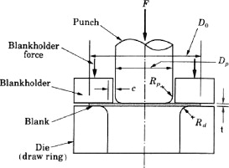
APPLICATIONS OF DEEP DRAWING:

- Kitchen Utensils
- Basin Sink
- Tubes
- Cylindrical Cups

STAGES OR STEPS IN DEEP DRAWING:
Zones
Bottom of Punch Zone | Deformation Zone | Flange Zone
It pushed by punch. | Entire plastic deformation takes place.  (Radial Flow + Bending + Straightening) | Radial Flow of material. (Flange May or May not exists)
CALCULATION OF REQUIRED BLANK DIAMETER:
$$One side Surface Area of blank = One side Surface Area of Final Component$$
Without Flange | With Flange
$$D_{b}=\sqrt{d^{2}+4dh} \left[For \left(D/r\right)≥20 \right]$$  Here, due to $D/r$ or $r$ there must be taken care of correction constant,  $$D_{b}=\sqrt{d^{2}+4dh}-0.5r \left[For 15≤\left(D/r\right)<20 \right]$$  $$D_{b}=\sqrt{d^{2}+4dh}-r \left[For 10≤\left(D/r\right)<15\right]$$ | $$D_{b}=\sqrt{d_{2}^{2}+4d_{1}h} \left[For \left({d_{1}}/r\right)≥20 \right]$$  Here, due to $D/r$ or $r$ there must take care of correction constant,  $$D_{b}=\sqrt{d_{2}^{2}+4d_{1}h}-r \left[For 15≤\left({d_{1}}/r\right)<20 \right]$$  $$D_{b}=\sqrt{d_{2}^{2}+4d_{1}h}-2r \left[For 10≤\left({d_{1}}/r\right)<15\right]$$
Where, $d =OD of Cup$  $$D_{b}=OD of Sheet Blank,$$  $$h=Out Side Height of Cup,$$ | $$d_{1}=OD of Cup,$$  $$d_{2}=OD of Cup Flange,$$  $$r_{p}=r_{d}=r$$
For Spherical End Deep Drawn Component: $D_{b}=\sqrt{2d^{2}+4dh}$ |  | Hemispherical Cup: $D_{b}=\sqrt{2}d$
PROBLEMS IN DEEP DRAWING:
- Non-Uniform thickness component in deep drawing: Due to friction, the deformation At upper portion of cup of on the wall is different than deformation at the lower portion of the cup on the wall. Hence, non-uniform thickness of the wall is generated.
- Crack Form near the bottom portion of the wall: Due to above reason some time, it’s observed that crack is formed near the bottom portion of the wall.
IRONING: Ironing avoids non uniform thickness of the component during deep drawing by reducing clearance in between some portion. ($c=0.9 to 0.95*t$)
Ironing to achieve a more uniform wall thickness in a drawn cup: 1) Start of process, 2) Material pass through less clearance area and due to lateral force, material flows upward, hence thinning and elongation of wall takes place.
CORNER CRACKS IN DEEP DRAWN COMPONENT:
Due to bending and excessive continuous force acting at the lower bend portion, continues plastic deformation Thinning of wall is observed. Hence stress concentration increases at that portion. hence, crack is formed.
Another Way we can say that bend portion is less strain harden than, the portion which is straighten. Hence due to strain hardening effect continuously plastic deformation increases.
METHODS TO ELIMINATE CORNER CRACKS:
- NO OF STAGES: By optimising no of stages, cracks can be eliminated.
FORMABILITY: Ability of the material to undergo maximum plastic deformation before fracture takes place.
$$Formability Property Index (FPI)={D_{b}}/{d_{\min{before crack generate}}}$$ | $$1.6≤FPI≤2.3$$
- Limiting Draw Ratio (LDR): Practically LDR is not constant. It Changes in each stage.
$$LDR=\frac{Dia. Before Draw}{Dia. After Draw}≅FPI$$
HARD: $1.6≤LDR≤2.0$ | DUCTILE: $2.0≤LDR≤2.3$ |  | Std LDR = 2.0
Find number of stages n =? ($d_{f},h_{f}, LDR is given$)
Stage 1:  Step 1: Find $d_{1}$ from ${LDR}_{1}={D_{b}}/{d_{1}}.$  Step 2: if $d_{1}>d_{f},$ Second Stage Required ($n≠1$). |  | Stage 2:  Step 1: Find $d_{2}$ from ${LDR}_{2}={d_{1}}/{d_{2}}.$  Step 2: if $d_{2}>d_{f},$ Next Stage Required ($n≠2$).
Let, Height of cup after first stage = $h_{1}$ & Height of cup after Second stage = $h_{2}$
Method 1:
$$D_{b}=\sqrt{d_{1}^{2}+4d_{1}h_{1}}$$ | $$D_{b}=\sqrt{d_{2}^{2}+4d_{2}h_{2}}$$
Method 2:
$$\frac{π}{4}d_{1}^{2}+πd_{1}h_{1}=\frac{π}{4}d_{2}^{2}+πd_{2}h_{2}$$
- Draw Reduction Ratio (DRR):
$$DRR=\frac{Dia. Reduction}{Dia. Before Draw}=\frac{D-d}{D}$$ | $$d=D(1-DRR)$$ |  | $$\%DRR=\left(\frac{D-d}{D}\right)100$$
Find number of stages n =? ($d_{f},h_{f}, DRR is given$)
Stage 1:  Step 1: Find $d_{1}$ from $d_{1}=D_{b}(1-{DRR}_{1})$.  Where, $D_{b}=\sqrt{d_{f}^{2}+4d_{f}h_{f}}$  Step 2: if $d_{1}>d_{f},$ Second Stage Required ($n≠1$). |  | Stage 2:  Step 1: Find $d_{2}$ from $d_{2}=d_{1}(1-{DRR}_{2})$.  Step 2: if $d_{2}>d_{f},$ Second Stage Required ($n≠2$).

DRAWING LOAD OF FORCE:
Drawing load calculation is very difficult to calculate because of (Wall Friction + Flange Friction + Strain Hardening). So, impartial relation is developed. $σ_{ut}$ is used in the equation because of strain hardening.
$$P\left(in N\right)=πdt σ_{ut}\left(\frac{D_{b}}{d}-C\right)$$ | C = Frication factor = 0.7 (Std. Value),  By neglecting Friction C = 0,  $$P=πt σ_{ut}D_{b}$$
Here, $d$ & $D_{b}$ is considered only for first stage. If stage is increase change this value as $d=d_{n}$ & $D_{b}=d_{n-1}$. Hence, we can find force in nth stage $P_{n}$.
DRAWING STRESS IN DEEP DRAWN COMPONENTS:
Stress in varying in each stage due to change of force in each stage.
$$σ_{n-Stage}={P_{n-Stage}}/{A_{C n-Stage}}$$ | $$A_{C n-Stage}=\frac{π}{4}\left[d_{n}^{2}-{(d_{n}-2t)}^{2}\right]$$
WORK DONE OR ENERGY:
First Stage: $E_{1}=P_{1}h_{1}$ | Second Stage: $E_{2}=P_{2}(h_{2}-h_{1})$ | n Stage:$E_{n}=P_{n}(h_{n}-\sum{h_{n-1}})$

BLANK HOLDING FORCE (BHF):  Due to lifting of sheet metal during operation there is a change of folding take place. Due to folding, deterioration of the surface finish is happed. To avoid deterioration blank holder/ Stripper plate is used with spring.  Here, the optimum value must be selected for the blank holding force (Else Shearing or High friction or high punching force effects may take place) ${BHF}_{n}=(1/3)$ $P_{n}$. | NATURE OF STRESS GENERATED IN PARTIALLY DRAWN COMPONENT: 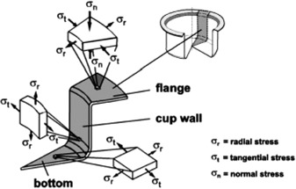
DEFECTS IN DEEP DRAWN COMPONENTS:
- Wrinkles: It can be avoided by using stripper plate with high BHF.
- Wrinkling in the flange: wrinkling in a drawn part consists of a series of ridges that form radially in the undrawn flange of the work part due to compressive bucking.
- Wrinkling in wall: if & when the wrinkled flange is drawn into the cup these ridges appears in the vertical wall.
- Earing: this is the formation of irregularities called ears in the upper edge of a deep drawn cup, caused by anisotropy in the sheet metal. If the material is perfectly isotropic, ears do not form. (Fig. d)
To avoid earing effect trimming allowance is given.$D_{total}=D_{b}+2{ \left(T.A.\right)}_{radial}=D_{b}+{\left(T.A.\right)}_{Diametral}$
- Surface Scratches: It can occur on the drawn part if the punch and die are not smooth or if lubrication is insufficient.
- Corner Cracks or Fracture:
Tearing: It’s an opening crack in the vertical wall, usually near the base of the drawn cup, due to high tensile stresses that cause thinning and failure of the metal at this location. This type of failure can also occur as the metal is pulled over a sharp die corner.
- Orange Peel: During sheet metal forming the individual grains in the metal tend to deform independentaly to each other. As a result, the grains stand out in relief on the surface. The large amount of defromaton, the more apperent is the effect.
- Stretcher Strain: (Fig. f)
- Low Carbon steel exhibit a behaviour which is calles yield point elongation, involving upper and lower yield points.
- This yield point elongation is usually on the order of a few percentage.
- In yield point elongation, a material yields at a given location; subsequent yielding occurs in adjacent areas where the lower yield point is unchanged.
- When the overall elongation reaches the yield point elongation, the entire specimen will undergo a uniform elongation.
- The behavoir of low carbon steel produces luder’s band (Also called stretcher strain marks or worms) on the sheet.
- These bands consist of elongated depressions on the surface of the sheet and can be objectionable in the final product because of it’s uneven surface apperance.
- These bands also can cause difficulties in subsequent coating and painting operation.
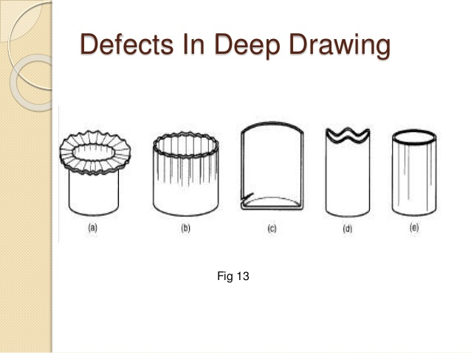 | 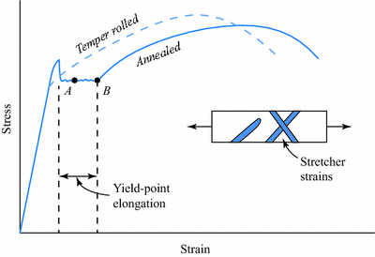
BENDING
Bending is a metal plastic deformation process in which a force is applied to a piece of sheet metal, causing it to bend at required angle and form the desired shape.$\left(σ_{yt}≤σ<σ_{ut}\right)$
- Bending of sheet metal  - Both compression and tensile elongation of the metal occur in bending.  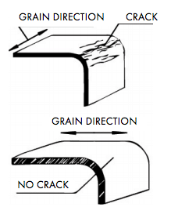 |  | 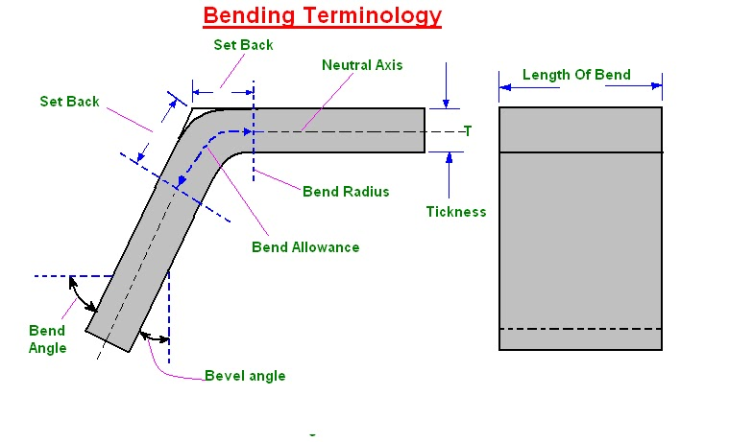
The effect of elongated inclusions (Stringers) on cracking as a function of the direction of bending with respect to the original rolling direction of the sheet.
$$L_{o}=A+B+β$$  $$β= R^{n}α^{rad}$$  $$R^{n}=R+0.5 t$$  $$α+α'=180°$$  $$R^{n}=R+K t$$ | K is taken because the sliding of layers at the bending location. Hence, neutral plane shifts.  $α=$ Angle of Arc, |  | $$K=1/3$$ For $R<2t$  $$K=1/2$$ For $R≥2t$  $L_{o}=$ Developed length,  $β=$ Bend Allowance,  $α=$ Bend Inclusion Angle, | $R=$ Bend Raidus,  $R^{n}=$ Bend Raidus of neutral plane,  $K=$ Bend Factor/ Streach factor

TYPES OF BENDING OPERATIONS  1) U-Bending, 2) V-Bending, 3) Edge Bending  Ratio of Force Required for Bending:  $$U:V:Edge=2:1:0.5$$  BENDING FORCE:  $$F_{max}∝\frac{1}{W}∝σ_{ut}∝t∝L$$ $$F_{max}∝\frac{σ_{ut} L t^{2}}{W}$$  Where, $W=$ Width of die opening.  WIDTH OF DIE OPENING: It’s minimum distance between centre of fillet provided on the punch and die/ Punch. | 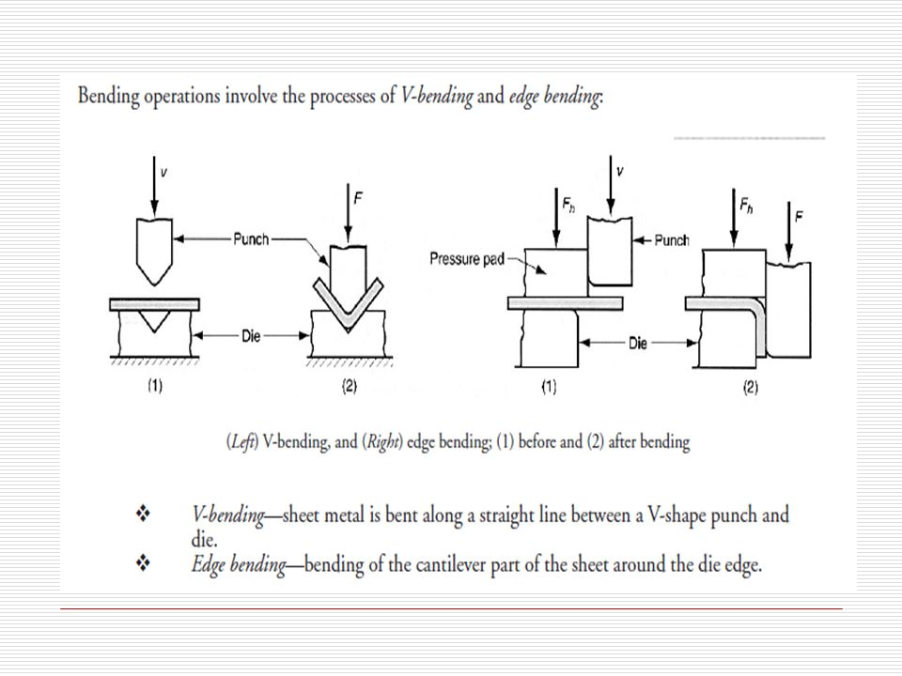
DIE FACTOR OR DIE CONSTANT: it’s used for compensation of losses in the die.
$$F_{max}=K\frac{σ_{ut} L t^{2}}{W}$$ | For U-Bending | For V-Bending | For Edge Bending
 | $$K=2.4…For W=16t$$  $$K=2.66…For W=8t$$ | $$K=1.2…For W=16t$$  $$K=1.33…For W=8t$$ | $$K=0.33$$
ELASTIC RECOVERY OR SPRING BACK IN SHEET METAL BENDING:
Spring-back is the geometric change made to a part at the end of the forming process when the part has been releases from the force of the forming tool. Upon completion of sheet metal forming, deep-drawn and stretch-drawn parts spring back and thereby the affect the dimensional accuracy of a finished part.
Due to Spring Back |  | $α$ Decreases |  | R increases
$$Spring Back Constant K={α_{f}}/{α_{i}}$$
$$K=1$$ | $$K=0$$ |  | $$K>1$$ |  | $$K<1$$
No Spring Back | Entirely Deformation recover |  | Negative Spring Back |  | Positive Spring Back
$$Spring Back∝Stress ∝1/E∝1/{Slop of Stress Strain}$$
MINIMUM BEND RADIUS:
$$R_{min}=Minimum Bend Radius \left(Without Crack Formation\right)∝α_{max}$$
$$R_{min}=t\left[\frac{50}{r}-1\right]$$ | Where, r = % reduction in Cross Section,  t = Thickness of the sheet,
MINOR SHEET METAL OPERATIONS:
PERFORATING: It involves the simultaneous punching of a pattern of holes in sheet metal. The hole pattern is usually for decorative purposes, or to allow passage of light, gas, or fluid.
NIBBLING: Punching a series of small overlapping slits or holes along a path to cut out a larger contoured shape is called nibbling operation.
LANCING:  - Lancing is a combined cutting and bending or cutting and forming operation performed in one step to partially separate the metal from the sheet.  - Creating a partial cut in the sheet, so that no material is removed. The material is left attached to be bent and form a shape such as tab, vent, or louver. | 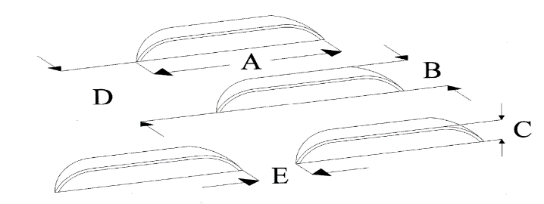
SLITTING:
- Shearing operations can be carried out by means of pair of circular blades similar to those in a can opener.
- In Slitting, the blades follow either a straight line, a circular path or curved path.
NOTCHING: To obtain the desired outline of blank, portions of the sheet metal are often removed by notching and semi notching. Notching involves cutting out a portion of metal form the side of the sheet or strip.
TRIMMING: Shaving or trimming is a finishing operation in which shearing-off of burrs from the cut edges is carried out in order to make the edge smooth and also impart dimensional accuracy.

